# SQL

## SQL Commands

Source: <https://livesql.oracle.com/apex/livesql/file/tutorial_K4J60LR7A87PV5DCA9V40OJRY.html>

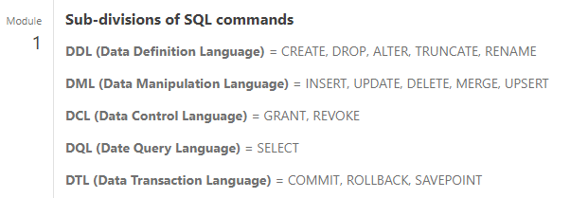

### Next Steps

From module 7

## Analytic functions

Source: <https://docs.oracle.com/cd/E11882_01/server.112/e41084/functions004.htm#SQLRF06174>

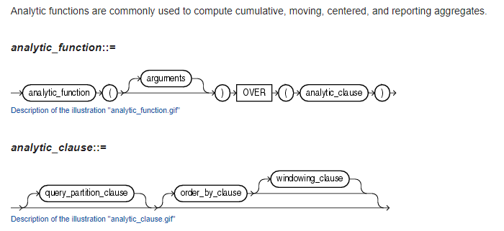

### Overview of Analytical Functions

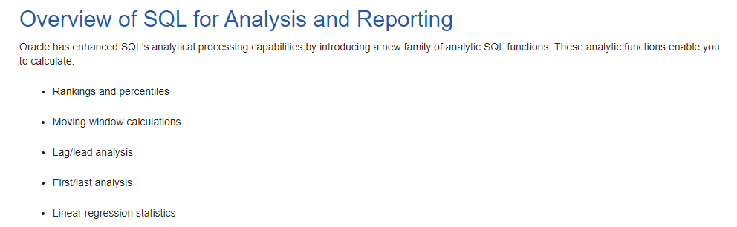

### Uses of Analytical Functions

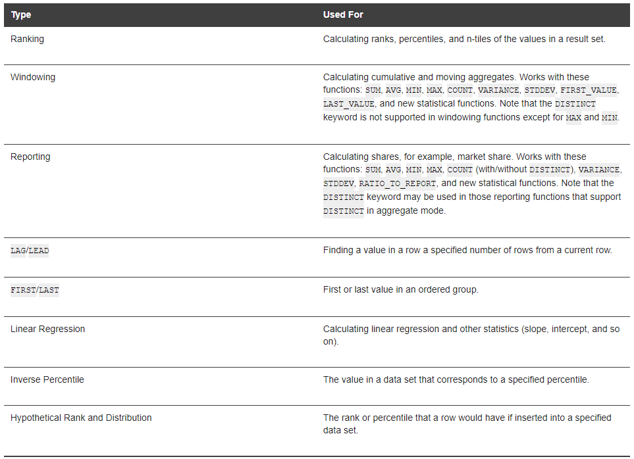

### Processing Order

